Windows Enabler

Overview:
Windows Enabler is a program that runs on Microsoft Windows 95/98/Me/NT4.0/2000. It allows the user to enable disabled windows and controls such as buttons and tick boxes and choose menu options that would normally be disabled. This is obviously a very dangerous practice if used recklessly but having said that, you’d be surprised at how often it comes in handy. Windows Enabler has a very simple user interface; it appears as an icon in the system tray and can be turned on and off simply by clicking on it. Windows enabler may be freely distributed as long as the entire package (or a superset) is distributed unaltered.

Installing:
Windows Enabler is a very simple utility and does not ship with an install program. The installation process is simple; just copy the two files (“Windows Enabler.exe” and “EnablerDLL.dll”) somewhere on your system and run “Windows Enabler.exe” to run the program. I normally place a shortcut to “Windows Enabler.exe” in my “Startup” program group so Windows Enabler is always available! Windows enabler does not make any registry entries or use any data files so uninstalling is accomplished by simply deleting its files (“Windows Enabler.exe” and “EnablerDLL.dll”).

Using Windows Enabler:
To run Windows Enabler execute the file “Windows Enabler.exe”; the simplest way to do this is to place a shortcut to it somewhere on your system such as the desktop, the start menu or the “Startup” program group. When Windows Enabler is running you should see one of the following icons in the system tray: or . To exit the Windows Enabler right click on the icon and choose “Quit” from the popup menu. An about box can be displayed by right clicking on the icon and choosing “About” from the popup menu. Left clicking on the icon toggles the Windows Enabler on and off. When the Windows Enabler is active the word “On” is superimposed on the icon as seen in the second icon above.

For example here is a dialog box from an application on our test machine. As you can see most of the controls on this dialog box are disabled and therefore can not be pressed or edited:
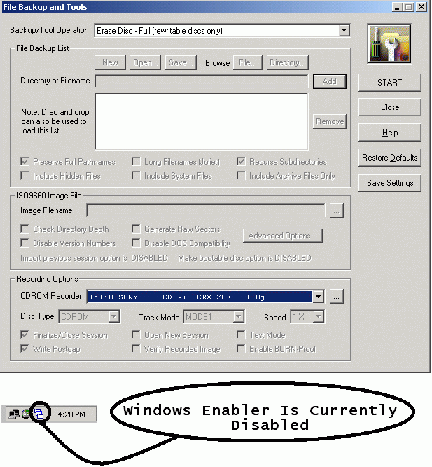

Here is the same dialog but we have used the “Windows Enabler” to enable some of the controls. We can now use these controls but how the software will react can vary greatly. Sometimes the results are disastrous, YOU HAVE BEEN WARNED!!
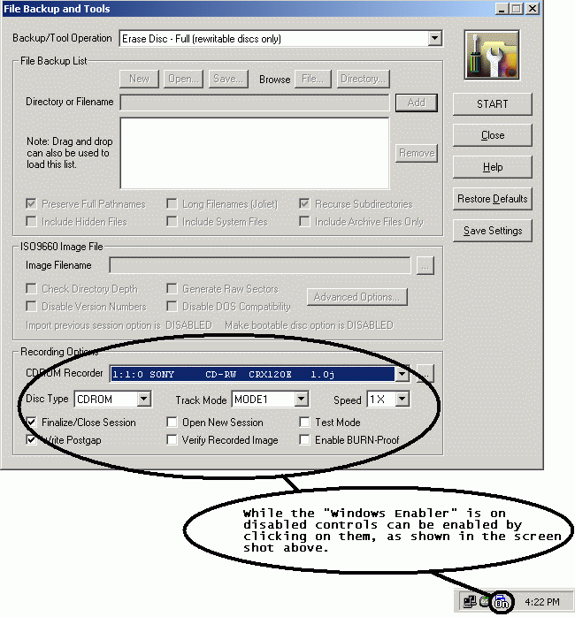

Here is another application from our test machine. Notice that all of the items in the “Actions” menu are disabled and cannot be selected;
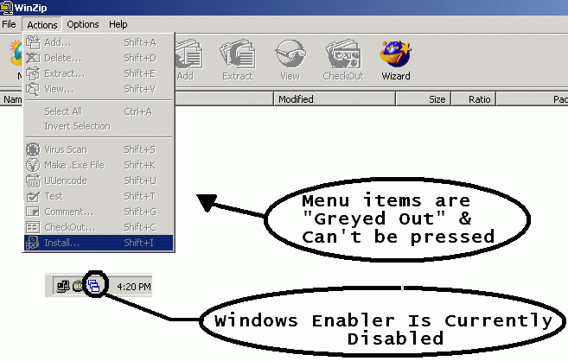

Here is the same application but now the menu items are all selectable. When the “Windows Enabler” is active all menu items are enabled;
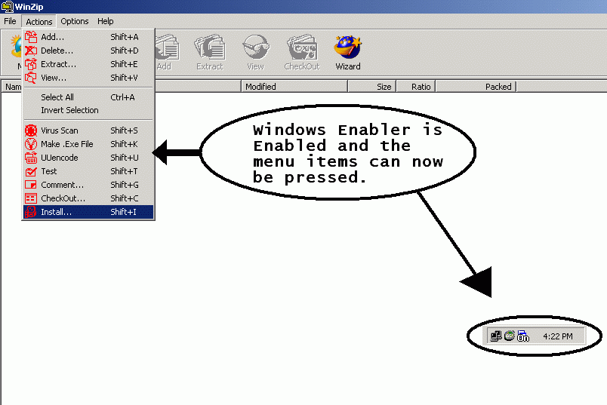

Although the “Windows Enabler” works on many applications it is obviously impossible and impractical to make an app that works 100% of the time. For example on some applications if you enable a button and press it the app is smart enough to ignore the command. In other cases the button is disabled almost immediately after being enabled.

Windows enabler may be freely distributed as long as the entire package (or a superset) is distributed unaltered.

If you have any questions, comments or wish to report a bug EMAIL me.

THE “WINDOWS ENABLER” IS PROVIDED “AS IS” WITHOUT ANY WARRANTY OF ANY KIND, EITHER EXPRESS OR IMPLIED, INCLUDING, WITHOUT LIMITATION, ANY WARRANTY OF MERCHANTABILITY AND FITNESS FOR A PARTICULAR PURPOSE.

Copyright © 2000 - 2001 Stephen Hewitt.

